Aotearoa New Zealand Sustainable Finance Taxonomy (NZ Taxonomy) second public consultation survey questions

*: Denotes a required field.
Red text: Provides functionality explanations and will not be text in the survey.

- Full name*
__________________________

- Email address*
You may be contacted in relation to your submission, or to receive updates on this consultation and process.
__________________________

- Do you represent your organisation’s collective view or your personal view?* (single-choice)
◯ I represent my organisation’s collective view
◯ I represent my personal view

- (If representing organisation’s collective view) Organisation*
__________________________

- (If representing organisation’s collective view) Position held
__________________________

- Which component(s) of the Taxonomy would you like to comment on? Please select all that apply.* (multiple-choice)
☐ Climate change mitigation criteria
☐ Climate change adaptation and resilience (A&R) criteria

- Please select the area(s) that best match your expertise:* (multiple-choice)
☐ Finance (including sustainable finance)
☐ Insurance
☐ Agriculture
☐ Forestry
☐ Other Land Use
☐ Environmental NGO
☐ Academia
☐ Legal
☐ Government
☐ Other (please specify) __________________________

Agriculture, Forestry and Other Land Use (AFOLU) climate change mitigation criteria

The climate change mitigation technical screening criteria (TSC) set the thresholds and requirements that an economic activity or measure must meet to be considered as making a substantial contribution to the climate change mitigation objective, while causing no significant harm to other environmental and social objectives, as safeguarded by the do no significant harm (DNSH) and minimum social safeguards (MSS) framework.
CSF received 48 responses to its June 2025 public consultation, 29 of which represent organisational views. Following the consultation and further engagement with industry bodies and key stakeholders in the AFOLU sector, Climate Bonds Initiative (CBI) – the technical delivery partner — supported by the technical groups, has updated the draft climate change mitigation TSC shared in June 2025.
In this consultation, we are seeking feedback particularly on the areas where feedback was contested or indicated that change was necessary but did not provide direction on that change. As such, the technical working groups have developed updates, but wider feedback is needed.
These areas are:
- The whole-of-farm activity, including the transition classification of this activity; and
- The do no significant harm criteria.
Please review the changes made and the explanations for why some suggestions were not incorporated here, before answering the questions below.
Questions in this section are only presented if you selected the option "climate change mitigation criteria" in Q6 above.

Whole-of-farm activity
Criteria for the whole-of-farm activity (activity A0 of the updated climate change mitigation substantial contribution criteria) have been updated based on the June 2025 consultation and input from Agricultural industry bodies and key players.
A whole-of-farm activity recognises farms that act across the entire farm to reduce emissions and increase or maintain carbon stocks.
- Both green and transition categories are NZ Taxonomy-aligned.
- Green primarily recognises farms that are already highly efficient and that have low absolute emissions, with limited scope for further improvement. The threshold is deliberately stringent and is expected to be met by only a small number of farms (mainly in viticulture and horticulture).
- Transition applies to farms that do not meet the stringent green threshold but are considered best-in-class within their industry, region, or farming system, and/or demonstrate substantial emissions reductions. Two pathways for transition alignment have been proposed to support both these applications. The technical groups are aware that industry benchmarks presented in Option 1 may not yet be readily available, however have proposed this as the best way to assess this option and that such benchmarks may soon be possible.
- The whole-of-farm activity is only one option for demonstrating taxonomy-alignment. Proponents may instead choose to align with the criteria for transition measures or align under the climate change adaptation and resilience criteria.

- What changes, if any, would you recommend to the green and/or transition whole-of-farm activity? (open comment box)
You may want to give consideration to whether the criteria will serve the intended purpose, and are useable and clear. If you disagree with the proposed alignment approach, please suggest alternative options for alignment. If your suggestion concerns a specific criterion, include the section name and bullet number (e.g., “Process and requirements > Bullet A”).

DNSH criteria
These criteria ensure that activities making a substantial contribution to an environmental objective (e.g., climate change mitigation) do not pose significant harm to other environmental objectives.
Feedback from the June 2025 consultation highlighted that the DNSH criteria needed to be both:
- More specific and detailed for stringency.
- Less complex and more general for usability.
Respondents also requested that:
- Resiliency be given more consideration.
- Erosion risk be addressed in both Agriculture and Forestry measures.
- Wording of generic DNSH criteria be updated to align with Australia’s final criteria.
- A new DNSH be introduced to prevent arable land conversion.
- Streamlined for new and small users.
These updates are reflected in the revised DNSH criteria here.

- Are you comfortable with the decision to make DNSH optional initially to encourage uptake, with a phased rollout for entities with 20 and more employees? (single choice)
◯ Yes
◯ No

Generic DNSH criteria
The generic DNSH criteria apply to all sectors and activities classified under the NZ Taxonomy (i.e., the Agriculture and Forestry Sectors, and all subsequent sectors).

- Are you comfortable with the pollution prevention and control and circular economy generic DNSH criteria adopting Australia’s final language to ensure interoperability? (single choice)
◯ Yes
◯ No – revert to the June consultation draft language
◯ No – alternative language should be used (please suggest wording that balances interoperability and local relevance, as well as ambition and usability) __________________________

Activity-specific DNSH criteria
Activity-specific DNSH criteria provide extra protections for environmental risks that may emerge from a specific activity.
The activity-specific DNSH criteria have been developed for the Agriculture and Forestry sectors, with additional sets of criteria to be developed for future sectors if/when they are developed.

- Please provide any feedback you have on the newly developed DNSH criteria for arable land conversion. (open comment box)

MSS criteria
These criteria ensure that activities making a substantial contribution to an environmental objective (e.g., climate change mitigation) do not result in adverse social outcomes, by requiring entities to comply with certain minimum social standards.
Feedback from the June 2025 consultation showed strong support for simplifying the MSS criteria to reduce complexity and compliance burdens for SMEs and encourage greater uptake.
You can view the revised MSS criteria here.

- Are you comfortable with the decision to make MSS requirements optional for organisations with 20 or more employees initially, and to permanently exempt organisations with fewer than 20 employees from MSS assessment? (single choice)
◯ Yes
◯ No

Other comments on technical screening criteria

- Please provide any other feedback on the updated climate change mitigation TSC (climate change mitigation SC criteria, DNSH, MSS). (open comment box)
When responding, please specify the specific component you are commenting on using this format: i) Summary of changes and rationales document > Table 1 > Row 1; and/or ii) Climate change mitigation technical screening criteria > Substantial contribution criteria > A. Agriculture > A.1 livestock grazing and animal production > A1.1 nutrient management.

Agriculture, Forestry and Other Land Use (AFOLU) climate change adaptation and resilience (A&R) criteria

NZ Taxonomy’s climate change A&R criteria include:
- The process-based approach criteria;
- The whitelist; and
- The do no significant harm (DNSH) criteria – with an added climate change mitigation DNSH component.
Please review the draft criteria and associated materials before answering the questions below.
Please respond to the questions in this section only if you selected the option "climate change adaptation and resilience (A&R) criteria" in Q6 above.

Process-based approach to climate change A&R
The process-based approach outlines the criteria for the approach that must be taken to climate change A&R activities or measures that can be aligned with the NZ Taxonomy.

- Are the proposed process-based approach criteria clear, usable, credibly making a substantial contribution to climate change A&R, and appropriately drawing on existing frameworks? (single-choice)
◯ Yes
◯ No

- What changes, if any, would you recommend to strengthen the process-based approach? (open comment box)

- Is there any additional relevant domestic guidance you would recommend to support users of the process-based approach? (open comment box)

Whitelist of climate change A&R measures
The whitelist is designed to provide an easy entry point for smaller entities and investors, by identifying climate change A&R activities/measures that carry minimal risk of maladaptation or significant environmental or social harm. These measures are automatically deemed eligible without requiring a full assessment against the process-based approach criteria.

- Are there any activities on the whitelist that pose risks of maladaptation/significant environmental or social harm, which should be removed? (single-choice)
◯ Yes (please specify which activities and explain why they should be removed) __________________________
◯ No

- Are there any additional activities that substantially contribute to climate change A&R with minimal risk of maladaptation/significant environmental or social harm, that are missing from the whitelist and should be added? (single-choice)
◯ Yes (please specify which activities and provide supporting evidence for their inclusion) __________________________
◯ No

- Please provide any further feedback you have on the whitelist. (open comment box)

Climate change mitigation DNSH criteria
These criteria (see pages 12, 23, 26, and 28 here) ensure that activities substantially contribute to climate change A&R do not pose significant risks to climate change mitigation.

- Please provide any feedback you have on the generic climate change mitigation DNSH criteria. (open comment box)

- Please provide any feedback you have on the specific climate change mitigation DNSH criteria. (open comment box)

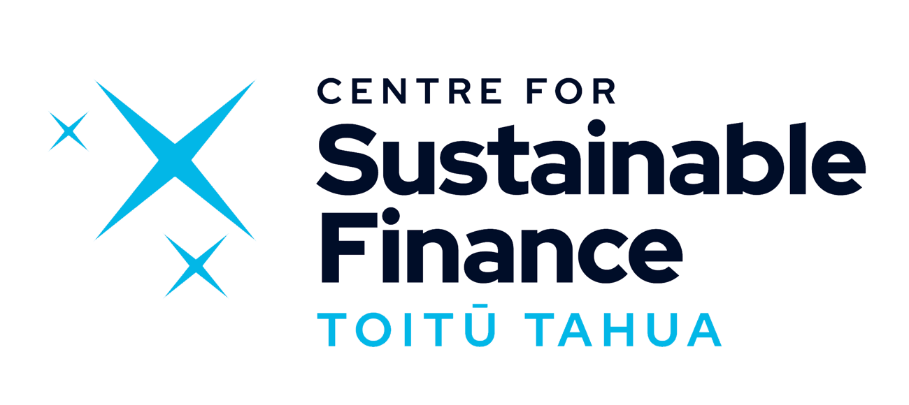

  - sustainablefinance.nz

If you have any questions about the survey or the consultation, please contact taxonomy@sustainablefinance.nz.

